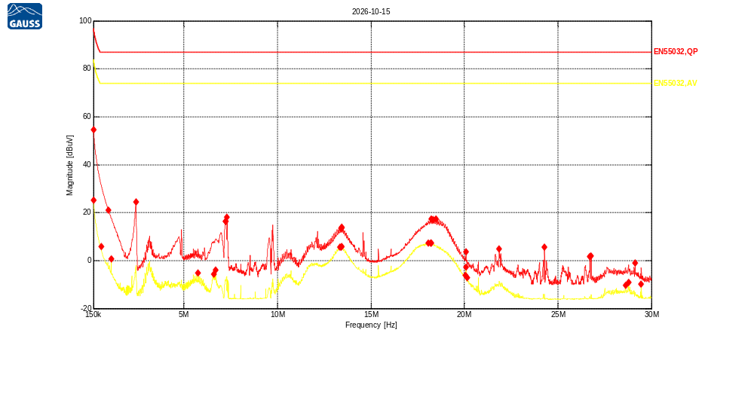
Receiver Model:
Protocol Number:
Serial Number:
Operation State:
Notes:
123123

Traces:
Trace | Start | Step | Stop | IF Bandwidth | Detector | Dwell time | Attenuation | Transducer | LISN | Notes
Scan2 | 150.0 kHz | 5.0 kHz | 30.0 MHz | 9kHz | QP | 200.0 ms | Auto | TDF1 | -
Scan1 | 150.0 kHz | 5.0 kHz | 30.0 MHz | 9kHz | Average | 200.0 ms | Auto | TDF1 | -

Transducers:
TDF1: LISN_DC

Limit lines:
EN55032,QP: EN55032 Cond,Asymmetric,Class A,QP, AAN, 150kHz-30MHz
EN55032,AV: EN55032 Cond,Asymmetric,Class A,Average, AAN,150kHz-30MHz
Scan2: 150.0 kHz, 5.0 kHz, 30.0 MHz; IF:9kHz, 200.0 ms QP, Att AutodB
f | Mag [dBuV] | Limit | Diff | Trans | Name | Comment
150 kHz | 54.59 | 97.00 | 42.41 | -0.32 | EN55032,QP
955.625336 kHz | 21.14 | 87.00 | 65.86 | -0.17 | EN55032,QP
2.42497609 MHz | 24.37 | 87.00 | 62.63 | -0.14 | EN55032,QP
7.21753135 MHz | 16.30 | 87.00 | 70.70 | -0.18 | EN55032,QP
7.2312636 MHz | 16.26 | 87.00 | 70.74 | -0.18 | EN55032,QP
7.27703777 MHz | 17.99 | 87.00 | 69.01 | -0.18 | EN55032,QP
13.4061987 MHz | 13.46 | 87.00 | 73.54 | -0.20 | EN55032,QP
13.4245084 MHz | 13.90 | 87.00 | 73.10 | -0.20 | EN55032,QP
13.4336632 MHz | 13.63 | 87.00 | 73.37 | -0.20 | EN55032,QP
18.2353733 MHz | 17.34 | 87.00 | 69.66 | -0.22 | EN55032,QP
18.3177668 MHz | 17.11 | 87.00 | 69.89 | -0.22 | EN55032,QP
18.4871312 MHz | 17.26 | 87.00 | 69.74 | -0.22 | EN55032,QP
20.0892271 MHz | 3.57 | 87.00 | 83.43 | -0.22 | EN55032,QP
21.8606873 MHz | 4.77 | 87.00 | 82.23 | -0.23 | EN55032,QP
24.2821407 MHz | 5.64 | 87.00 | 81.36 | -0.25 | EN55032,QP
26.712749 MHz | 1.57 | 87.00 | 85.43 | -0.29 | EN55032,QP
26.7722554 MHz | 1.88 | 87.00 | 85.12 | -0.29 | EN55032,QP
29.129625 MHz | -1.14 | 87.00 | 88.14 | -0.32 | EN55032,QP

Scan1: 150.0 kHz, 5.0 kHz, 30.0 MHz; IF:9kHz, 200.0 ms Average, Att AutodB
f | Mag [dBuV] | Limit | Diff | Trans | Name | Comment
150 kHz | 25.12 | 84.00 | 58.88 | -0.32 | EN55032,AV
561.967501 kHz | 5.96 | 74.00 | 68.04 | -0.18 | EN55032,AV
1.10210267 MHz | 0.79 | 74.00 | 73.21 | -0.17 | EN55032,AV
5.75733543 MHz | -5.27 | 74.00 | 79.27 | -0.17 | EN55032,AV
6.59042527 MHz | -5.71 | 74.00 | 79.71 | -0.18 | EN55032,AV
6.69570585 MHz | -4.06 | 74.00 | 78.06 | -0.18 | EN55032,AV
13.3421149 MHz | 5.57 | 74.00 | 68.43 | -0.20 | EN55032,AV
13.4107761 MHz | 5.53 | 74.00 | 68.47 | -0.20 | EN55032,AV
13.4245084 MHz | 5.81 | 74.00 | 68.19 | -0.20 | EN55032,AV
18.0660089 MHz | 7.27 | 74.00 | 66.73 | -0.22 | EN55032,AV
18.1850217 MHz | 7.31 | 74.00 | 66.69 | -0.22 | EN55032,AV
18.2262185 MHz | 7.25 | 74.00 | 66.75 | -0.22 | EN55032,AV
20.0571851 MHz | -6.11 | 74.00 | 80.11 | -0.22 | EN55032,AV
20.0892271 MHz | -2.76 | 74.00 | 76.76 | -0.22 | EN55032,AV
20.1487335 MHz | -7.11 | 74.00 | 81.11 | -0.22 | EN55032,AV
28.6169543 MHz | -10.29 | 74.00 | 84.29 | -0.31 | EN55032,AV
28.7908962 MHz | -9.11 | 74.00 | 83.11 | -0.31 | EN55032,AV
29.4637764 MHz | -9.81 | 74.00 | 83.81 | -0.32 | EN55032,AV

